September Week 1 Report - Brownian Motion and Geometric Brownian Motion
Project: AI/ML-Augmented Black-Scholes Framework for Option Pricing and Market-Risk Analysis
Plan reference: §15.4 (§15.4.1 - §15.4.6)
Primary text: Carol Alexander, Market Risk Analysis Volume I: Quantitative Methods in Finance, §I.3.7
Asset for the model-versus-data experiment: NIFTY 50 (^NSEI), 2 January 2015 - 31 December 2024
Submitted by: Sanskar
Contents
1. Objective and scope
2. Part A - standard normals and Brownian increments (tasks 1-2)
3. Part A - Brownian-motion paths (task 3)
4. Part A - moments and dependence on Δt (tasks 4-7)
5. Part A - independence and stationarity of increments
6. Part A - quadratic variation
7. Part B - GBM simulation and validation (§15.4.3)
8. Part B - the roles of μ and σ (§15.4.3)
9. Part B - the two drifts, and a clarification from the Week 1 review
10. Part B - calibration to NIFTY 50 (§15.4.4)
11. Part B - the model-versus-data experiment (§15.4.5)
12. Interpretation of model limitations (§15.4.6)
13. Conclusions

1. Objective and scope
September Week 1 establishes the stochastic process underlying the Black-Scholes model, and then tests that process against the empirical behaviour characterised in the previous report.
The learning objective (§15.4.1) is the Brownian increment
$$ΔW=W_{t+Δt}−W_{t}, ΔW∼N(0,Δt), ΔW=\sqrt{Δt} Z, Z∼N(0,1)$$
leading to the asset-price model
$$\frac{dS_{t}}{S_{t}}=μ dt+σ dW_{t}$$
All seven computational tasks of §15.4.2 were completed, together with §15.4.3 (GBM simulation), §15.4.4 (calibration to NIFTY) and §15.4.5 (the model-versus-data experiment).
# | Task (§15.4.2) | Report section
1 | Generate standard normal random variables | 2
2 | Generate Brownian increments | 2
3 | Construct complete Brownian-motion paths | 3
4 | Verify numerically that $E[ΔW]≈0$ | 4
5 | Verify $Var(ΔW)≈Δt$ | 4
6 | Repeat the experiment for different values of $Δt$ | 4
7 | Demonstrate that $SD(ΔW)∝\sqrt{Δt}$ | 4
Three sections go beyond the required tasks. Sections 5 and 6 test the defining properties of Brownian motion - independence, stationarity and quadratic variation - which normality alone does not guarantee. Section 6 in particular measures the property that produces the $1/2σ^{2}S^{2}V_{SS}$ term whose origin §15.5.3 question 2 asks about. Section 9 addresses the clarification requested in the Week 1 review.

2. Part A - standard normals and Brownian increments (tasks 1-2)
Everything rests on the quality of the generator, so it is verified before anything is built on it. With $n={10}^{6}$ the standard error of the sample mean is $1/\sqrt{n}=0.001$.
Statistic | Observed | Theory
Mean | +0.000458 | 0
Variance | 0.996596 | 1
Skewness | −0.003274 | 0
Excess kurtosis | +0.001145 | 0
The sample mean lies 0.458 standard errors from zero. Jarque-Bera on the first 5,000 draws gives $p=0.499$ - entirely consistent with normality.
Brownian increments then follow as $ΔW=\sqrt{Δt} Z$. At $Δt=1/252$ with $n=10,000$:
Statistic | Observed | Theory
$mean(ΔW)$ | +0.00028207 | 0
$var(ΔW)$ | 0.00400866 | $Δt$ = 0.00396825
$sd(ΔW)$ | 0.06331401 | $\sqrt{Δt}$ = 0.06299408
The scaling is $\sqrt{Δt}$, not $Δt$. This is the single most important structural fact about Brownian motion, and Section 4 tests it directly.

3. Part A - Brownian-motion paths (task 3)
A path is the cumulative sum of increments started at $W_{0}=0$:
$$W_{t_{k}}=\sum_{i=1}^{k}{Δ}W_{i}$$
Since $W_{t}∼N(0,t)$, the dispersion of the paths widens as $\sqrt{t}$. Eight paths are far too few to test this, so the moment checks use 2,000:
Statistic of $W_{T}$ | Observed | Theory
Mean | +0.0068 | 0 (0.31 standard errors)
Standard deviation | 0.9690 | $\sqrt{T}$ = 1.0000
Jarque-Bera $p$ | 0.978 | consistent with normal
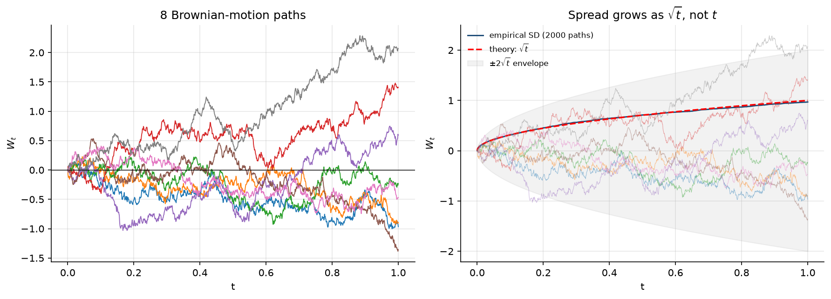
Figure 1. Left: eight Brownian-motion paths. Right: the empirical standard deviation across 2,000 paths against the theoretical $\sqrt{t}$, with the $±2\sqrt{t}$ envelope. The spread grows as a square root, not linearly.

4. Part A - moments and dependence on Δt (tasks 4-7)
Three claims were tested across nine values of $Δt$ spanning five orders of magnitude, from 1.0 down to $5×{10}^{−5}$, with $n=200,000$ draws at each.
A caution regarding task 4. The raw $\overline{ΔW}$ shrinks as $Δt$ falls, but this proves nothing - the whole scale is shrinking with it. The scale-free test is $\overline{ΔW}$ divided by its own standard error $\sqrt{Δt/n}$, which should remain of order 1 irrespective of $Δt$.
$Δt$ | mean / s.e. | var / $Δt$ | sd / $\sqrt{Δt}$
1.0 | −1.028 | 1.006092 | 1.003042
0.25 | −0.645 | 1.003293 | 1.001645
1/52 | −0.246 | 0.997726 | 0.998862
1/252 | −0.896 | 1.001292 | 1.000646
1/1000 | +1.794 | 0.998646 | 0.999323
1/5000 | −0.388 | 0.998266 | 0.999132
1/20000 | −1.914 | 1.002644 | 1.001321
Task 4: the normalised mean stays between −2.11 and +1.79 at every $Δt$ - consistent with zero throughout.
Task 5: the maximum deviation of $var(ΔW)/Δt$ from unity is 0.0061.
Task 7. Rather than asserting the proportionality, the regression
$$\text{ln}SD(ΔW)=a+b\text{ln}Δt$$
was fitted, with theory requiring $b=1/2$ and $a=0$.
Parameter | Fitted | Theory
Slope $b$ | 0.500245 ± 0.000127 | 0.5
Intercept $a$ | +0.001825 | 0
$R^{2}$ | 1.000000 | -
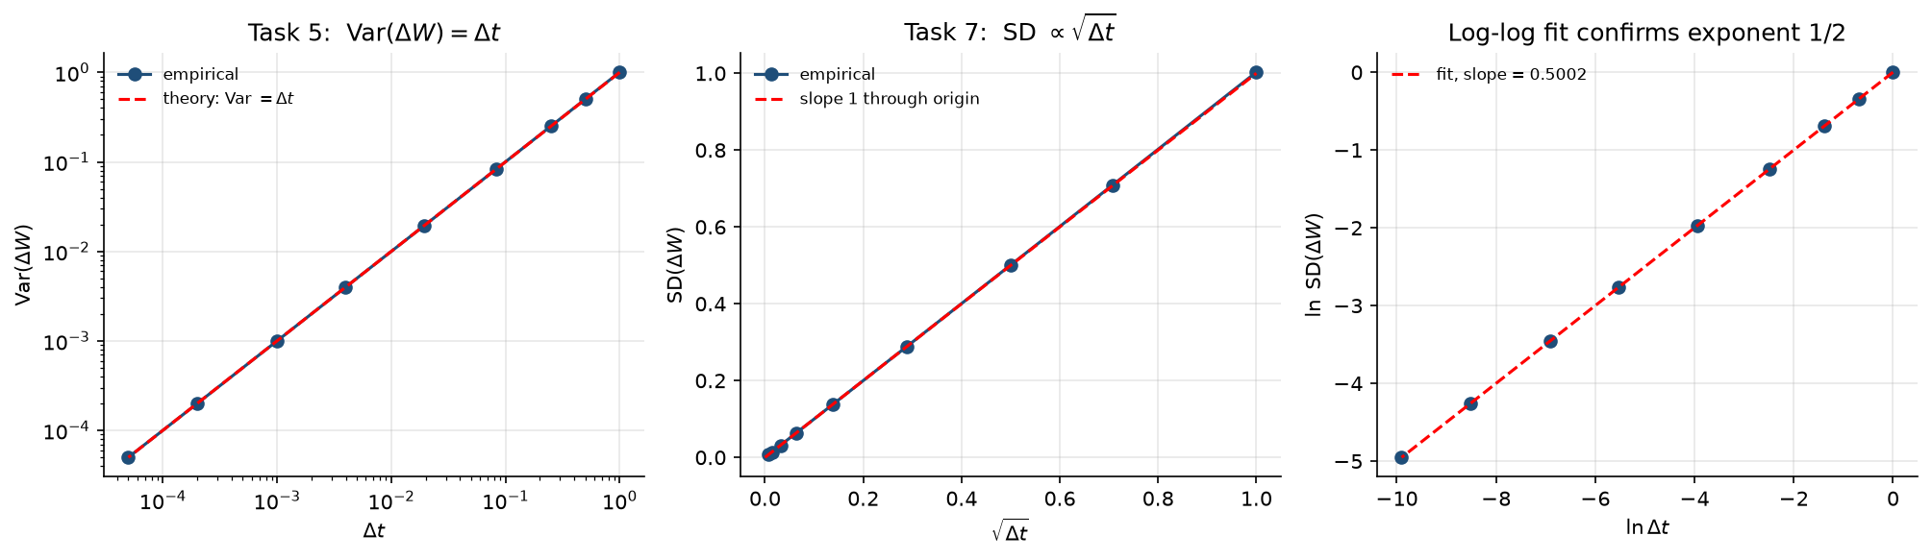
Figure 2. Left: $Var(ΔW)$ against $Δt$ on log axes. Centre: $SD(ΔW)$ against $\sqrt{Δt}$, falling on a line of slope 1 through the origin. Right: the log-log fit, whose slope of 0.5002 confirms the exponent.
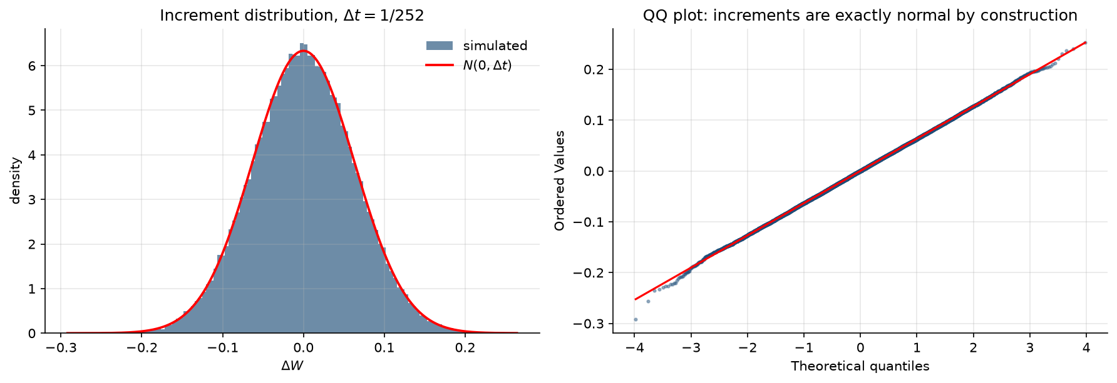
Figure 3. Increment distribution at $Δt=1/252$ against $N(0,Δt)$, with the corresponding QQ plot. The points lie on the line because the increments were generated normal - this is a build check rather than a finding. The contrast with the equivalent NIFTY plot from the previous report, which showed excess kurtosis above 20, is the subject of Section 11.

5. Part A - independence and stationarity of increments
Not required by §15.4.2. Normality alone does not make a process Brownian motion. Two further properties are required: increments over non-overlapping intervals must be independent, and their distribution must depend on $Δt$ only, not on $t$ - stationarity.
With $n=200,000$ increments at $Δt=1/252$, all ten autocorrelations fall inside the 95% band:
Quantity | Value
Maximum $|$autocorrelation$|$, lags 1-10 | 0.004263
95% band $1.96/\sqrt{n}$ | ±0.004383
Spread of standard deviations across 8 blocks | 0.001300
Comparison: $\sqrt{Δt}$ | 0.062994
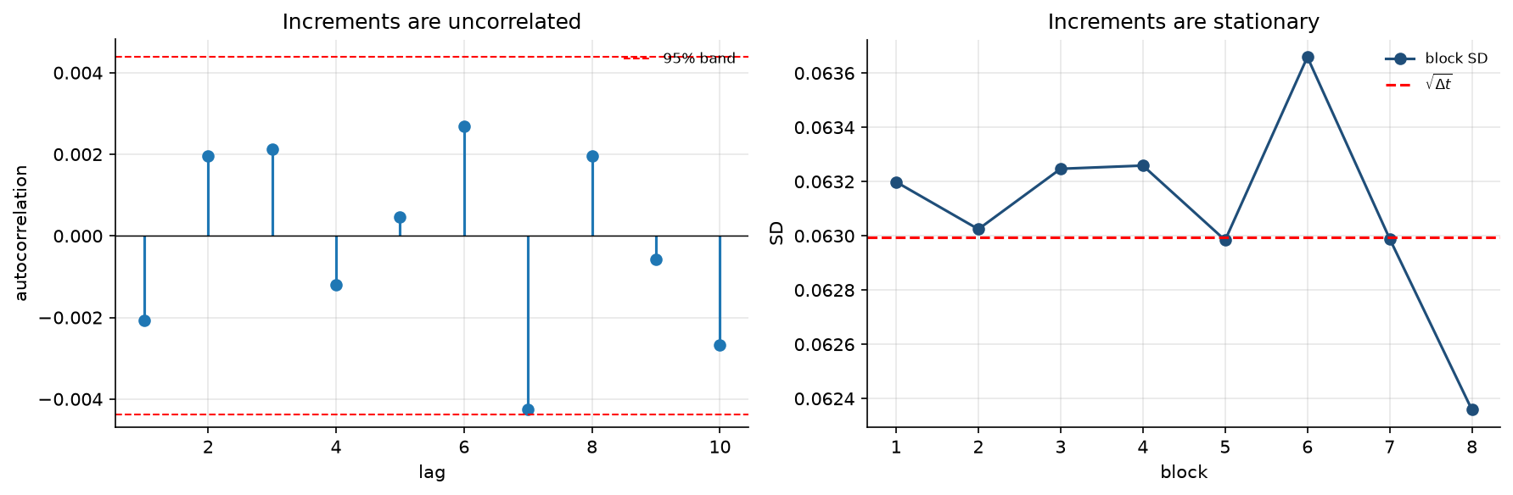
Figure 4. Left: autocorrelation of increments at lags 1-10 against the 95% band. Right: standard deviation across eight equal blocks of the sample against $\sqrt{Δt}$.
This result should be held against the NIFTY 50 return series, which showed pronounced volatility clustering. Returns themselves are close to uncorrelated, but their magnitudes are not - which breaks precisely the stationarity property verified here. Section 11 measures the difference.

6. Part A - quadratic variation
Not required by §15.4.2. Included because §15.5.3 question 2 asks where the term $1/2σ^{2}S^{2}V_{SS}$ comes from.
Partitioning $[0,T]$ into $n$ steps and computing three sums:
$$∑(ΔW)^{2}→T \text{(finite, non-zero)}, ∑|ΔW|→∞, ∑(ΔW)^{3}→0$$
For an ordinary differentiable function all three would vanish. The convergence of the first is not eyeballed: $Var​\left(∑(ΔW)^{2}\right)=2T^{2}/n$ exactly, so the standard error is $T\sqrt{2/n}$ and the normalised deviation must remain of order 1.
$n$ steps | $∑(ΔW)^{2}$ | s.e. | normalised deviation | $∑|ΔW|$
10 | 1.275320 | 0.447214 | +0.62 | 2.92
100 | 1.113638 | 0.141421 | +0.80 | 8.52
1,000 | 1.018547 | 0.044721 | +0.41 | 25.48
10,000 | 1.006502 | 0.014142 | +0.46 | 80.09
100,000 | 0.994982 | 0.004472 | −1.12 | 251.30
The normalised deviation stays between −1.58 and +0.80 across four orders of magnitude in $n$. That is what convergence in $L^{2}$ means.
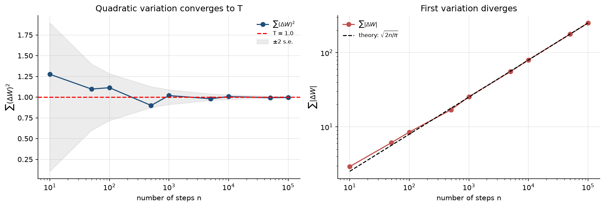
Figure 5. Left: quadratic variation converging to $T$, with the $±2$ standard-error band. Right: the first variation diverging as $\sqrt{2n/π}$.

Why this matters
For a smooth function, the Taylor expansion $df=f′ dx+1/2f″(dx)^{2}+⋯$ discards the $(dx)^{2}$ term as negligible. For Brownian motion it cannot be discarded: $(ΔW)^{2}$ accumulates at rate $dt$, written compactly as
$$(dW)^{2}=dt$$
Retaining that term is the entire difference between ordinary and Itô calculus. Applied to $V(S,t)$ under $dS=μS dt+σS dW$ it produces
$$dV=\left[V_{t}+μSV_{S}+\underset{\text{from }(dW)^{2}=dt}{\underset{⏟}{1/2σ^{2}S^{2}V_{SS}}}\right]dt+σSV_{S} dW$$
which is the expression given in §15.5.1, and the second-derivative term survives into the Black-Scholes PDE. Week 2 derives this; the present section has measured the fact it rests on.
Separately, $∑|ΔW|→∞$ states that Brownian paths have infinite length over any interval - continuous everywhere, differentiable nowhere. This is why $dW/dt$ does not exist and why stochastic calculus is required at all.

7. Part B - GBM simulation and validation (§15.4.3)
The analytical GBM solution is
$$S_{t}=S_{0}\text{exp}\left[\left(μ−1/2σ^{2}\right)t+σW_{t}\right]$$
This expression is simulated directly rather than by an Euler discretisation of $dS=μS dt+σS dW$. Stepping the analytical solution is exact - it carries no discretisation bias at any step size, and cannot produce negative prices.
Validated against four analytical results with $S_{0}=100$, $μ=0.10$, $σ=0.20$, $T=1$, using 200,000 paths of 252 steps:
Quantity | Simulated | Theory | Relative error
$E[S_{T}]$ | 110.515674 | 110.517092 | 1.28e−05
$Var(S_{T})$ | 499.414062 | 498.463922 | 1.91e−03
$E[\text{ln}S_{T}]$ | 4.685115 | 4.685170 | 1.17e−05
$Var(\text{ln}S_{T})$ | 0.040092 | 0.040000 | 2.29e−03
Jarque-Bera on $\text{ln}S_{T}$ gives $p=0.575$: $S_{T}$ is lognormal and $\text{ln}S_{T}$ is normal, exactly as the model states. One-step log returns have mean $+0.00031724$ against a theoretical $+0.00031746$, and variance $0.00015869$ against $0.00015873$.

8. Part B - the roles of μ and σ (§15.4.3)
To isolate the effect of each parameter, every panel uses identical random shocks - the generator is re-seeded before each simulation. Any visible difference between panels is therefore caused by the parameter and not by different noise.
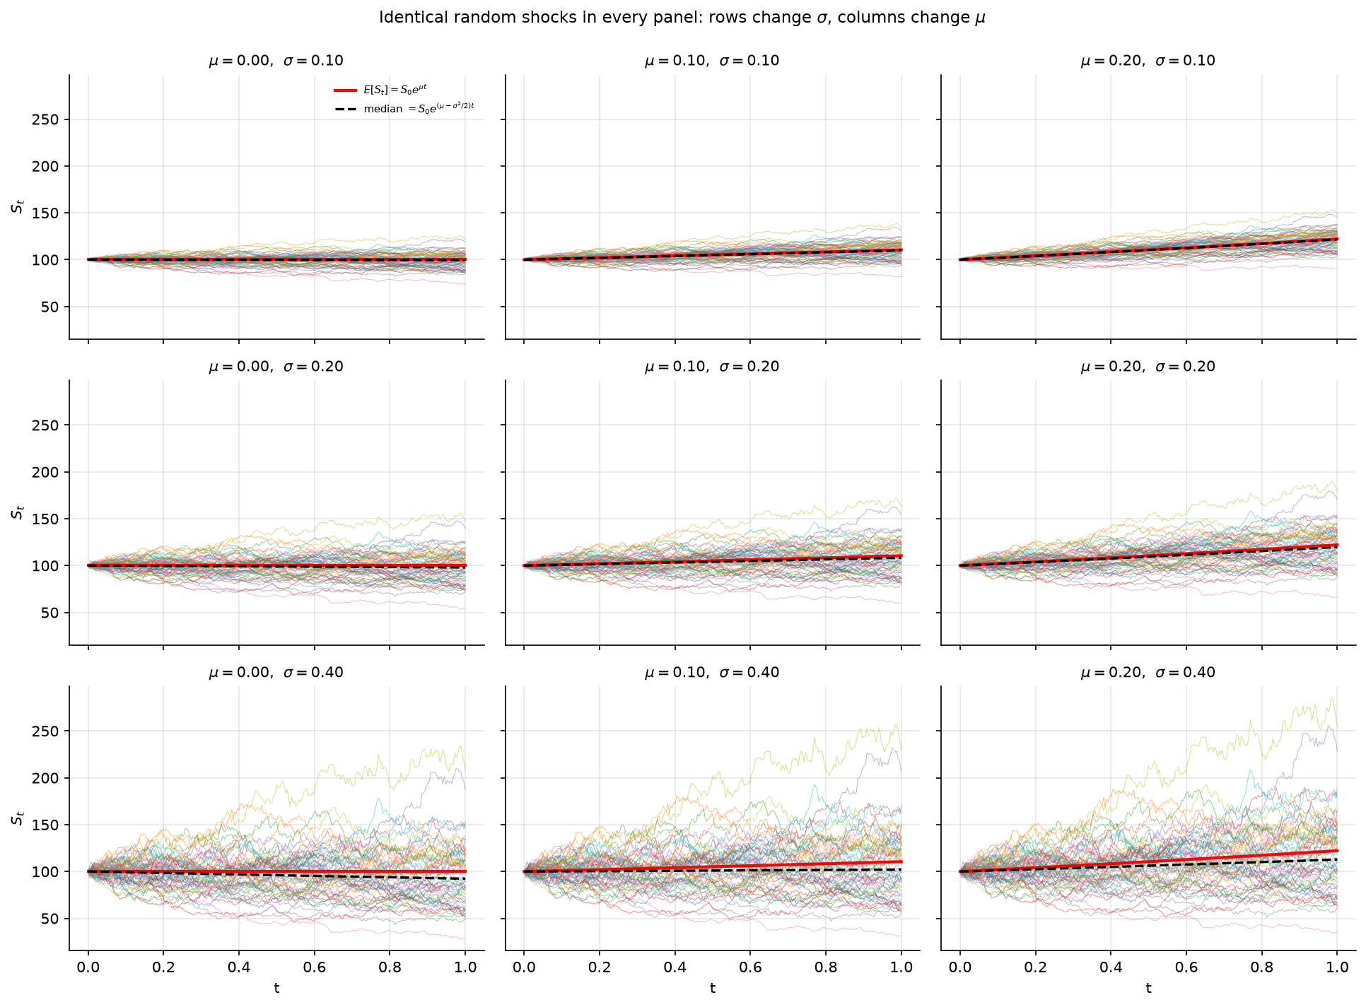
Figure 6. GBM paths for $μ∈\{0,0.10,0.20\}$ across columns and $σ∈\{0.10,0.20,0.40\}$ down rows. The red line is $E[S_{t}]=S_{0}e^{μt}$; the black dashed line is the median $S_{0}e^{(μ−σ^{2}/2)t}$.
Reading the grid:
- Across a row ($μ$ increasing): the whole bundle tilts upward; the spread is unchanged.
- Down a column ($σ$ increasing): the bundle fans out, and the median line falls away from the mean line.
So $μ$ sets the trend and $σ$ sets the dispersion - but $σ$ does something further. Through the $−1/2σ^{2}$ term it drags the median below the mean. At $σ=0.40$ the median grows at approximately 2% while the mean grows at 10%.

9. Part B - the two drifts, and a clarification from the Week 1 review
GBM has two distinct growth rates, and conflating them is a standard error:
$$\underset{\text{the average outcome}}{\underset{⏟}{E[S_{T}]=S_{0}e^{μT}}} \text{versus} \underset{\text{the typical outcome}}{\underset{⏟}{E[\text{ln}S_{T}]=\text{ln}S_{0}+\left(μ−1/2σ^{2}\right)T}}$$
Tested across six values of $σ$ with 200,000 paths each:
$σ$ | growth of $E[S_{T}]$ | $E[\text{ln}S_{T}]/T$ | gap | $σ^{2}/2$ | s.e.
0.05 | 0.099922 | 0.098672 | 0.001250 | 0.001250 | 0.000112
0.10 | 0.100071 | 0.095073 | 0.004998 | 0.005000 | 0.000224
0.20 | 0.100104 | 0.080137 | 0.019967 | 0.020000 | 0.000447
0.30 | 0.099942 | 0.055091 | 0.044852 | 0.045000 | 0.000671
0.40 | 0.098677 | 0.018637 | 0.080040 | 0.080000 | 0.000894
0.60 | 0.100383 | −0.079121 | 0.179504 | 0.180000 | 0.001342
Maximum absolute discrepancy: 4.96e−04, which is within Monte Carlo error at every $σ$.

The clarification requested in the Week 1 review
The Week 1 report observed that the empirical gap $\overline{R}−\overline{r}$ measured on NIFTY 50 data was numerically very close to ${\hat{σ}}^{2}/2$, and presented this as the Itô correction identified in the data. That framing was too strong, and the distinction is worth stating precisely.
The empirical gap is a Taylor/Jensen identity in sample moments. Expanding the exact relation $r=\text{ln}(1+R)$ and averaging,
$$\overline{R}−\overline{r}=1/2E[R^{2}]−1/3E[R^{3}]+1/4E[R^{4}]−⋯$$
This is algebra applied to the concavity of the logarithm. It holds for any collection of small numbers, requires no probability model, and would appear identically in a fat-tailed sample, a skewed sample, or a deterministic alternating sequence with no randomness whatsoever. It therefore has no power to confirm geometric Brownian motion or Itô’s lemma.
The result in this section is a different statement. $E[\text{ln}S_{T}]=\text{ln}S_{0}+(μ−1/2σ^{2})T$ is a property of the continuous-time process, exact at every $σ$ with no truncation, arising from Itô’s lemma applied to $f=\text{ln}S$ where the term $1/2f″(S)(dS)^{2}$ survives because $(dW)^{2}=dt$ - the quadratic-variation property measured in Section 6.
The two agree numerically under GBM, because GBM is constructed so that its log returns have mean $(μ−1/2σ^{2})Δt$. They are not the same claim, and only the second is what Itô’s lemma asserts.
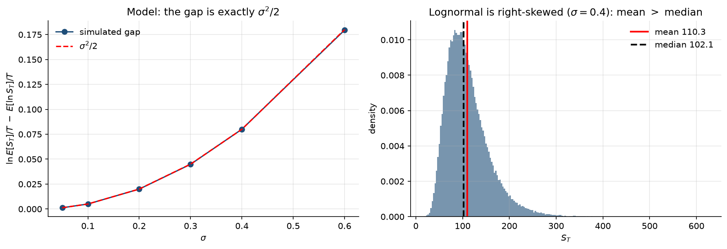
Figure 7. Left: the simulated gap between the growth of $E[S_{T}]$ and of $E[\text{ln}S_{T}]$ against $σ^{2}/2$. Right: the lognormal distribution of $S_{T}$ at $σ=0.40$, showing the mean lying to the right of the median.

10. Part B - calibration to NIFTY 50 (§15.4.4)
§15.4.4 gives $σ≈0.167$ from the previous stage. Rather than hard-coding this value, the estimates are recomputed from the cached price series so that the calibration is reproducible.
Quantity | Value
Period | 2 January 2015 - 31 December 2024
Return observations | 2,458
Daily mean log return | +0.00042126
Daily standard deviation of log return | 0.01054451
Annualised $σ$ | 0.167389
Annualised $μ$ | 0.120167
The drift is set so that $μ−1/2σ^{2}=0.106157$, which equals the empirical annualised mean log return. GBM is therefore matched to the data on both the first and the second moment - which is what §15.4.5 means by “the same $μ$ and $σ$”. Anything the model subsequently fails to reproduce is a genuine failure of the model rather than an artefact of calibration.

11. Part B - the model-versus-data experiment (§15.4.5)
A GBM return sample was generated with the same number of observations, the same mean and the same volatility as the NIFTY sample. Everything that was not calibrated was then compared.
Statistic | NIFTY 50 | GBM | Difference
Mean | 0.000421 | 0.000381 | −0.000040
Standard deviation | 0.010545 | 0.010840 | +0.000295
Annualised volatility | 0.167389 | 0.172076 | +0.004687
Skewness | −1.407643 | −0.021647 | +1.385997
Excess kurtosis | 20.413236 | 0.165022 | −20.248214
Minimum | −0.139038 | −0.037110 | +0.101928
Maximum | 0.084003 | 0.039072 | −0.044931
Mean and standard deviation agree, because they were the calibration targets. Skewness and kurtosis do not, and were never targeted.
Normality test | Jarque-Bera | $p$-value | Verdict
NIFTY 50 | 43,304.26 | 0.000 | rejected
GBM | - | 0.236 | not rejected

Tail event frequencies
Threshold | NIFTY observed | GBM observed | Normal expected | NIFTY ratio | GBM ratio
$|z|>2$ | 97 | 115 | 111.84 | 0.9× | 1.0×
$|z|>3$ | 29 | 11 | 6.64 | 4.4× | 1.7×
$|z|>4$ | 15 | 0 | 0.156 | 96.3× | 0.0×
$|z|>5$ | 10 | 0 | 0.0014 | 7,096.3× | 0.0×
The last two rows are decisive. In matched samples of identical size, mean and volatility, the market delivered fifteen days beyond four standard deviations and ten beyond five; the model produced none at either threshold.
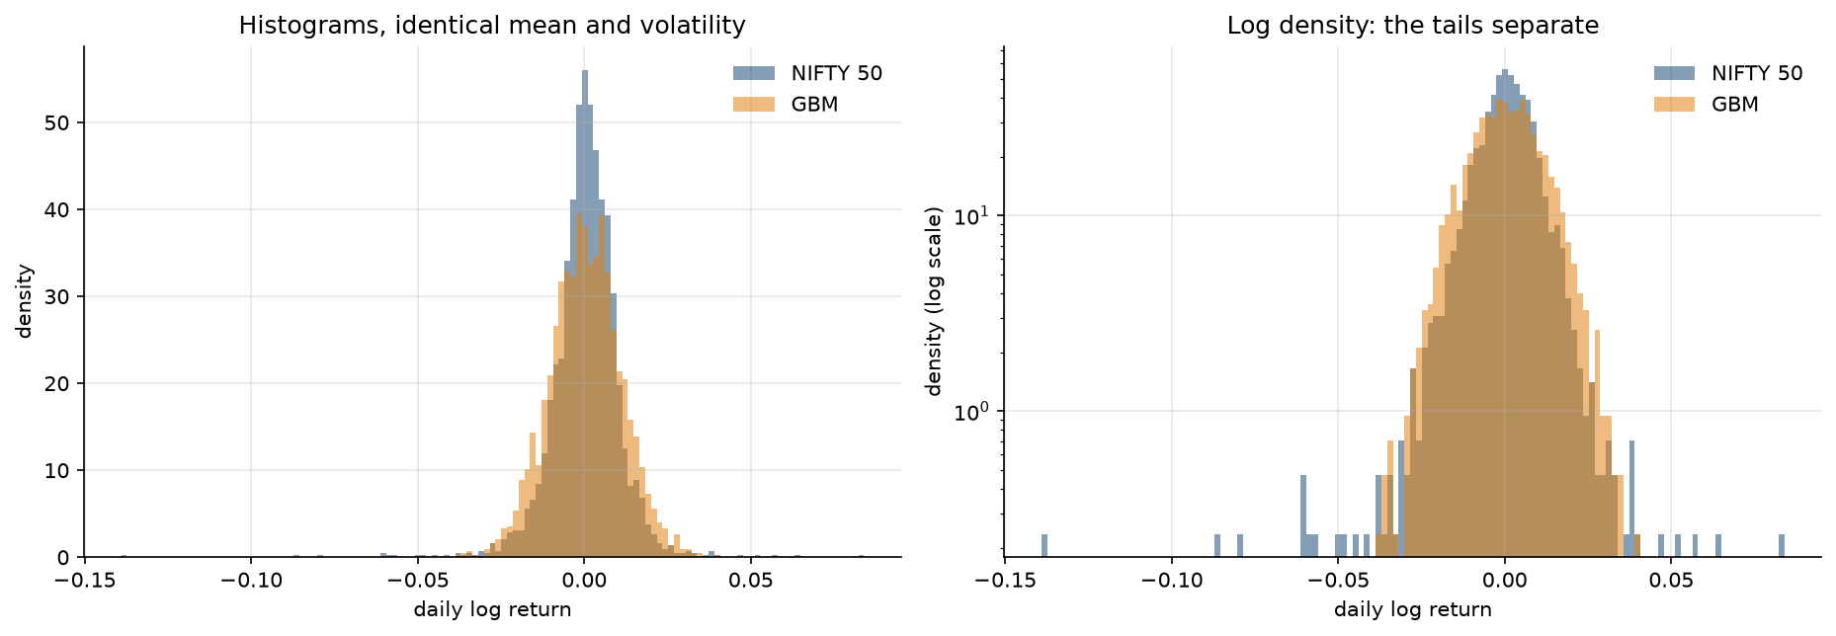
Figure 8. Empirical and simulated return histograms on linear and logarithmic density scales. On the linear scale the two distributions appear broadly similar; on the log scale the tails separate decisively.
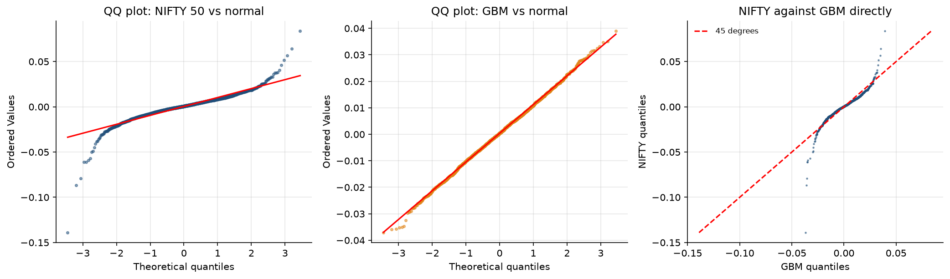
Figure 9. Left: QQ plot of NIFTY returns against the normal, showing the S-shape characteristic of heavy tails, with a markedly larger deviation in the left tail. Centre: the same plot for the GBM sample, which lies on the line. Right: NIFTY quantiles plotted directly against GBM quantiles - the departure from the 45-degree line is the model error.
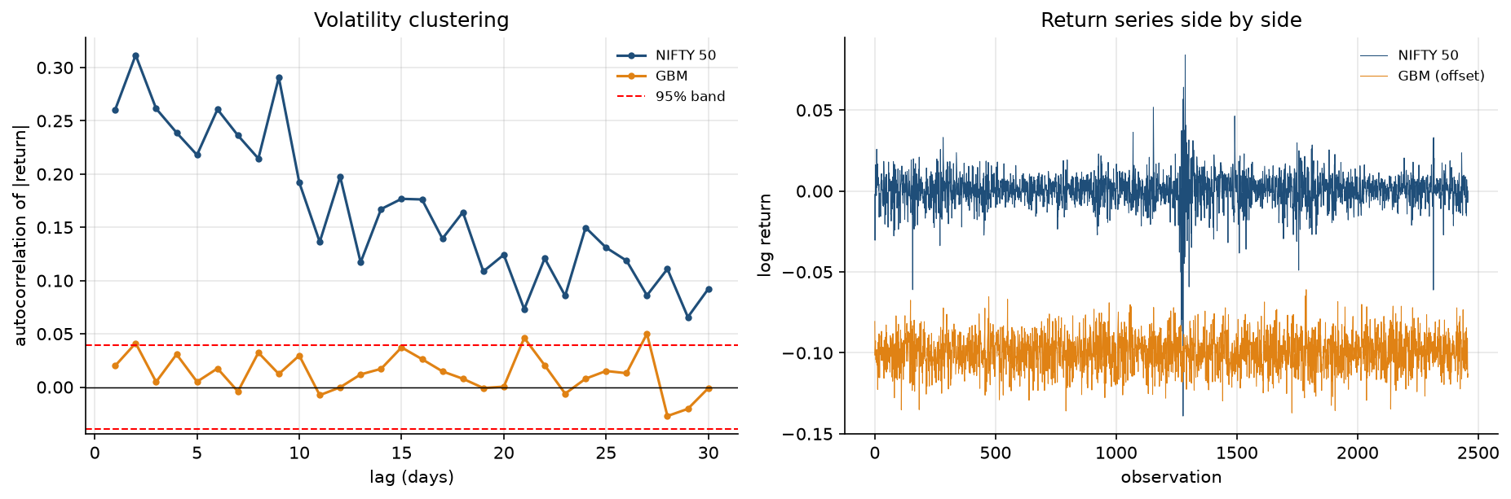
Figure 10. Left: autocorrelation of $|r_{t}|$ over 30 lags. The NIFTY series shows strong, slowly decaying positive autocorrelation; the GBM series sits inside the 95% band at every lag. Right: the two return series plotted side by side, with the GBM series offset for clarity.
Figure 10 shows a failure that none of the moment-based diagnostics can detect. GBM increments are independent and identically distributed by construction, so the model cannot generate volatility clustering at all.

12. Interpretation of model limitations (§15.4.6)

Principal question (§15.4.5)
If GBM is calibrated to the same mean and volatility, does it reproduce the distributional behaviour observed in the actual market data?

Answer: no.
What GBM reproduces
- The mean and standard deviation exactly - but only because these were the calibration targets. Matching them is not evidence in the model’s favour.
- Positivity of prices, which is why the process is geometric rather than arithmetic.
- The broad visual character of a price path over long horizons.
What GBM fails to reproduce
Property | NIFTY 50 | GBM
Skewness | −1.41 | ≈ 0
Excess kurtosis | 20.41 | ≈ 0.17
Days beyond 4σ | 15 | 0
Days beyond 5σ | 10 | 0
Volatility clustering | strong, persistent | absent by construction

Consequences for the project
Black-Scholes is derived under exactly these dynamics and inherits every one of these failures. Two consequences follow directly and will be met later in the project.
A single constant $σ$ cannot price all strikes consistently. Inverting the formula on observed market prices returns different implied volatilities at different strikes - the volatility smile - which is logically impossible if the model is true. This is encountered in September Week 3 (§15.6.3) and again with real option data in October.
Tail risk is understated. A model assigning probability $5.7×{10}^{−7}$ to a five-sigma day, in a market that delivers roughly one per year, will misprice deep out-of-the-money options and understate portfolio risk under stress. This is the subject of the November market-risk stage.

13. Conclusions
- All seven computational tasks of §15.4.2 were completed, together with §15.4.3-§15.4.5.
- The relation $SD(ΔW)∝\sqrt{Δt}$ was verified by fitting the exponent rather than asserting it: 0.500245 ± 0.000127 against a theoretical 0.5, with $R^{2}=1.000000$ across five orders of magnitude in $Δt$.
- Increments were confirmed independent and stationary - all autocorrelations inside the 95% band, block moments flat.
- Quadratic variation converges to $T$ while first variation diverges. The normalised deviation of $∑(ΔW)^{2}$ from $T$ remains of order 1 from $n=10$ to $n={10}^{5}$. This is the property that forces Itô’s lemma and produces the second-derivative term in the Black-Scholes PDE.
- The GBM simulator reproduces all four analytical lognormal moments to relative errors between ${10}^{−5}$ and ${10}^{−3}$.
- The identity $E[\text{ln}S_{T}]=\text{ln}S_{0}+(μ−1/2σ^{2})T$ holds within Monte Carlo error at every $σ$ tested. This is distinguished in Section 9 from the Taylor/Jensen identity observed in the Week 1 empirical data, which is a different statement with no power to confirm the model.
- GBM calibrated to the NIFTY mean and volatility does not reproduce the observed distributional behaviour. It matches the first two moments by construction and fails on skewness, kurtosis, tail frequencies and volatility clustering. Most starkly, it produced zero days beyond four standard deviations where the market produced fifteen.
Position going into Week 2. These failures are now measured rather than assumed. The Black-Scholes derivation that follows can therefore be understood as a rigorous consequence of assumptions already known to be false in specific, quantified ways - which is the difference between using a model and believing it.

